Practical Debug & Refine Prototype Worksheet

Section 1: Trace Table Analysis
Choose one function or method from your Pygame project (e.g., update(), check_collision()). Copy the code snippet below and complete the trace table for two different sets of input/state.
# Paste your selected function here

Step  (Wave) | Variable(s) State Before | Input/Condition | Expected Output/State | Actual Output/State | Notes (Error?)
1 | World.enemyList = [] | {“zombie”:3} | [“zombie”, “zombie”, “zombie”] | [“zombie”, “zombie”, “zombie”] | Successful: test passed
2 | World.enemyList = [] | {“zombie”:5} | [“zombie”, “zombie”, “zombie”, “zombie”, “zombie”] | [“zombie”, “zombie”, “zombie”, “zombie”, “zombie”] | Successful: test passed
3 | World.enemyList = [] | {“skeleton”:10} | [“skeleton”, “skeleton”, “skeleton”, “skeleton”, “skeleton”, “skeleton”, “skeleton”, “skeleton”, “skeleton”, “skeleton”] | [“skeleton”, “skeleton”, “skeleton”, “skeleton”, “skeleton”, “skeleton”, “skeleton”, “skeleton”, “skeleton”, “skeleton”] | Successful: test passed

Section 2: Breakpoint Debugging
- Open your project in your IDE. Identify a line where unexpected behaviour occurs.
- Set a breakpoint and run in debug mode. Record variable values at the breakpoint.
Breakpoint Location (file:line) | Variable | Expected Value | Actual Value | Action Taken
gameStates.py:217 | enemyType | ‘zombie’ | ‘zombie’ | None needed

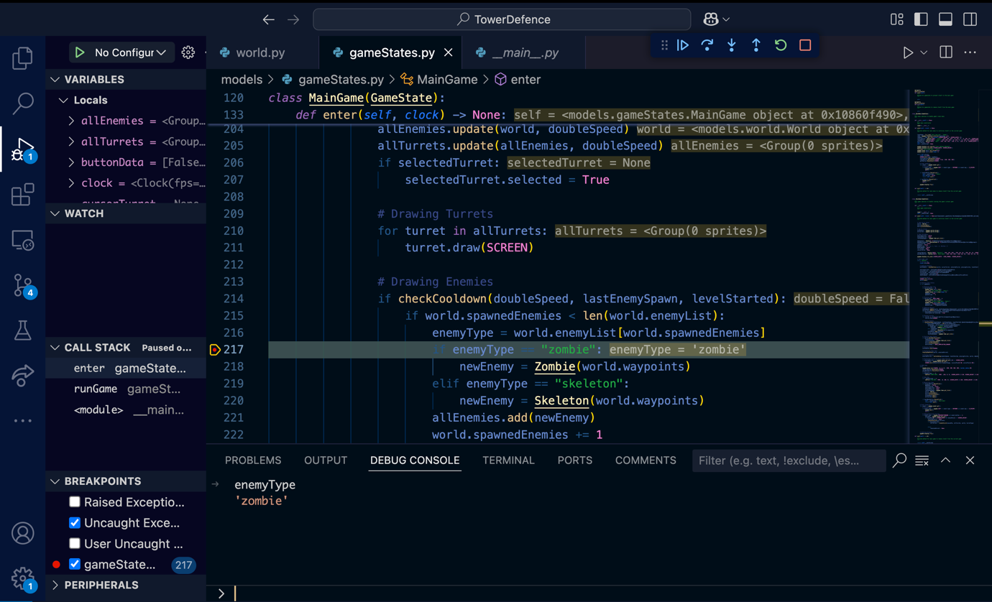

This breakpoint is testing to ensure that the enemies have been processed correctly and that the enemyType variable is indeed the intended/correct value, which in this case was ‘zombie’ hence the test was passed successfully.

Section 3: Peer Code Review
Partner with a classmate. Swap game prototypes. For each area below, test your peer’s game and record findings.
Test Case / Edge Case | Expected Behaviour | Actual Behaviour | Severity (Low/Med/High) | Suggested Fix
Duck moves to the edge of the map | Duck stops at the wall and does not continue beyond the boundaries | Duck stopped at the wall | N/A | N/A
Duck moves onto win tile | Duck moves smoothly, once it reaches the win tile the program stops | Duck smoothly moved to win tile and the program stopped once the tile was reached | N/A | N/A

Section 4: Desk-Checking (Manual Simulation)
Select a short method or loop from your game. Write down each step of execution manually to detect logic errors.
Code:
In World class:
# Processing Enemy Spawning
def processEnemies(self) -> None:
"""
Method to handle the spawning of enemies in waves
"""

if self.wave < WAVE_COUNT + 1:
enemies = ENEMY_COUNT[self.wave -1]

for enemy_type in enemies:
enemies_to_spawn = enemies[enemy_type]
for i in range(enemies_to_spawn):
self.enemyList.append(enemy_type)

Desk-Check Steps: ( ) = variable/line value when tested
- Check if there’s another wave left (True)
- If there is then get the enemy data from the constant list of dictionaries for enemy counts ({‘zombie’:3})
- For every type of enemy in the dictionary (‘zombie’)
- Get number of enemies of that type for this wave (3)
- Add the enemy type that many times to the enemy list for that wave (‘zombie’, ‘zombie’, ‘zombie’)
Issues identified: None found, meaning the logic of this method is correct and there are no logical errors to be noted, and the method should work as intended.

Section 5: Bug Log & Resolution
Keep track of every bug you fix in your prototype.
Bug ID | Description | Type (Syntax/Logic/Runtime) | Debug Technique Used | Fix Implemented | Verified (Y/N)
1 | Issue with the path to assets | Runtime Error | Desk Checking (original table used has been lost) | Changed the path to no longer start from the ‘Year 12’ parent file but as the working directory being the main TowerDefence file | Y
2 | Font not initialised Error | Runtime Error | Compiler | Moved the pygame.init() and pygame.mixer.init() functions to before importing the GameStateManager class | Y
3 | Enemy Sprite Rotating incorrectly | Logic error | Print Statements | Changed the logic so that instead of rotating the enemy’s sprite is flipped in the X if the angle between the next waypoint and the enemy is > ±175˚which gives the enemies a much smoother/natural motion | Y

Note – more visible in my github commits available at: https://github.com/General-Hex/tower-defence/tree/Backtracked

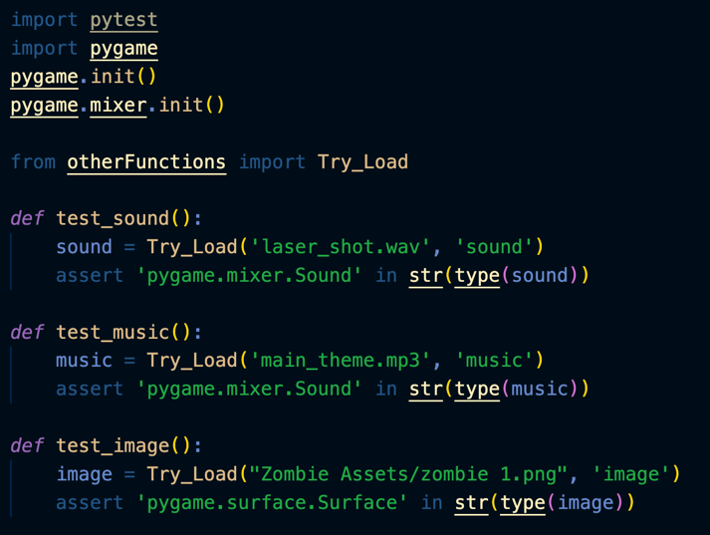
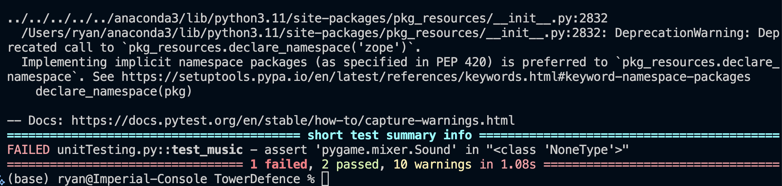
Section 6: Unit Testing

Wrote unit test to test the Try_Load() function which is used to import sound and image assets for the game. However, the music test failed as it appears the function returned None instead of a sound class.

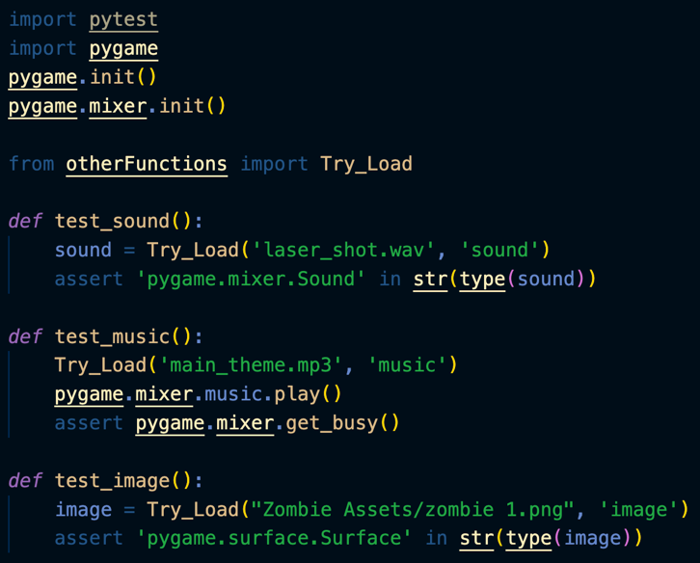
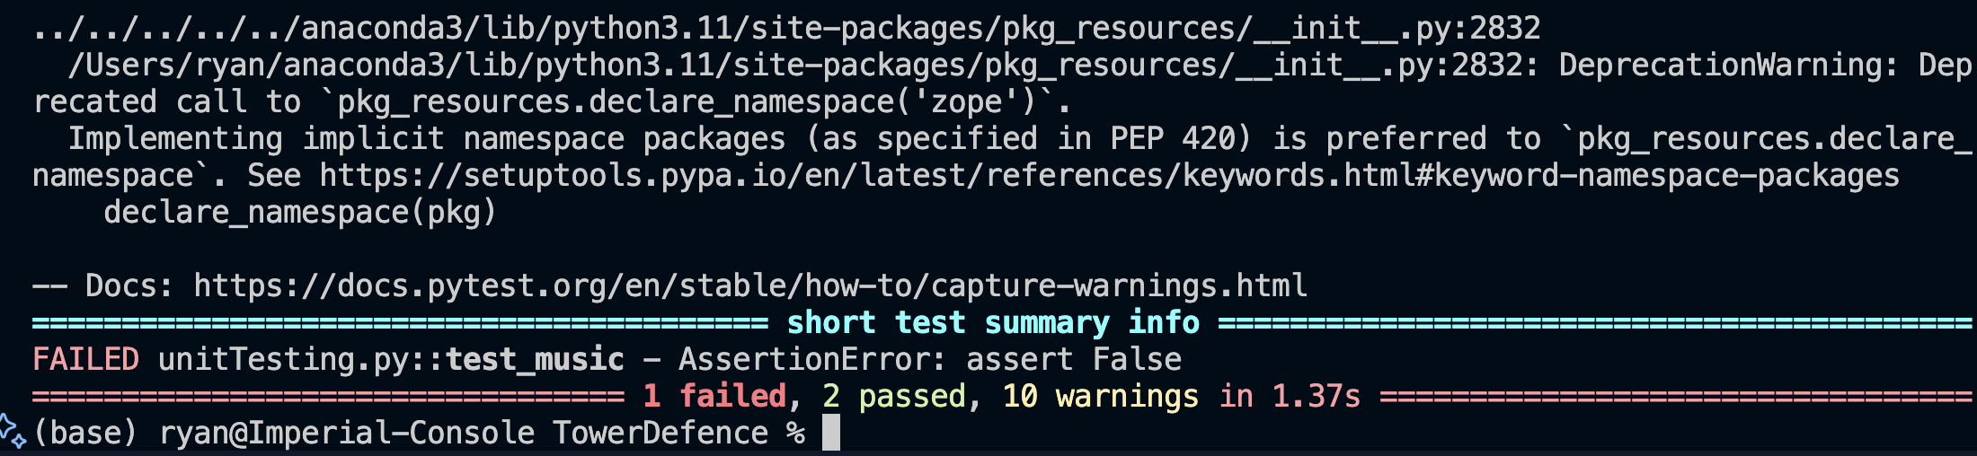

I realised my mistake was that the music section does not return any values instead it loads it into the pygame.mixer which can then be played. So I tried instead using the pygame.mixer.get_busy() function which checks if the music is playing however this too failed as apparently the music was not playing.

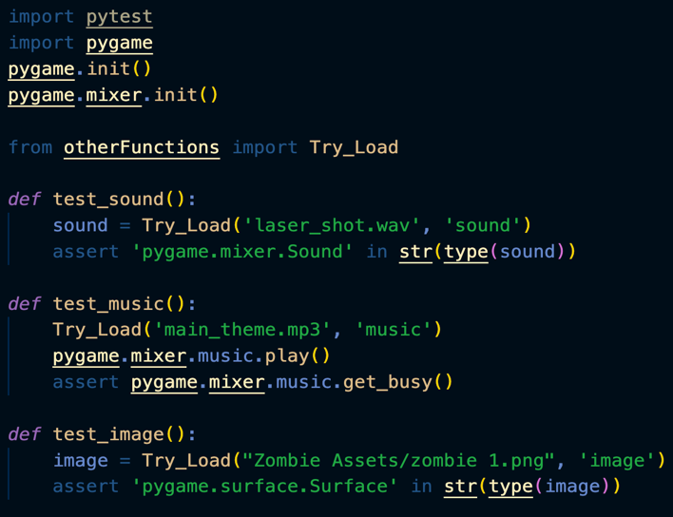
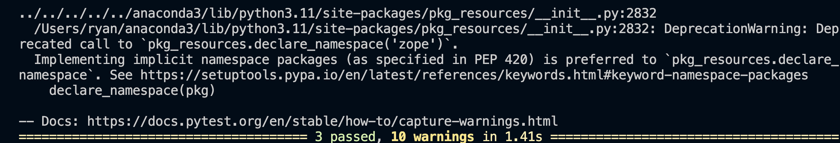

I once again realised my silly mistake was that I used pygame.mixer.get_busy() instead of pygame.mixer.music.get_busy(). Fixing this issue allowed for the proper testing of the function and the function was able to pass all three tests smoothly

Section 7: Maintenance Refactor Task

Choose one function from your project that is complex or repetitive. Rewrite it following best practices: single responsibility, clear naming, and comments.
Original Code:
# Rotating Enemy Image
def __updateRotation(self) -> None:
"""
Method to update rotation of enemy sprite
"""

distance = self.target - self.pos
self.__rotationAngle = math.degrees(math.atan2(-distance[1], distance[0]))

if int(self.__rotationAngle) < -175:
rotateX = True
elif int(self.__rotationAngle) > 175:
rotateX = True
else:
rotateX = False

if rotateX:
self.image = self.image = pygame.transform.flip(self.originalImage, True, False)
else:
self.image = self.image = pygame.transform.flip(self.originalImage, False, False)
self.rect = self.image.get_rect()
self.rect.center = self.pos

Refactored Code:
# Rotating Enemy Image
def __updateRotation(self) -> None:
"""
Method to update rotation of enemy sprite
"""

distance = self.target - self.pos
self.__rotationAngle = math.degrees(math.atan2(-distance[1], distance[0]))
rotateX = int(self.__rotationAngle) < -175 or int(self.__rotationAngle) > 175

self.image = self.image = pygame.transform.flip(self.originalImage, rotateX, False)
self.rect = self.image.get_rect()
self.rect.center = self.pos
Benefits of Refactor: Removed redundant ‘if’ statements causing clutter, simplified logic and made overall method much clearer and more succinct which in future will allow for easier debugging and maintenance.

Reflection
Briefly reflect on how debugging and peer feedback improved your game prototype:
Overall, the various testing methods and peer feedback allowed me to ensure the reliability and correctness of my methods, functions and algorithms of my program ensuring that as I develop the program further and expand it there will not be any missed bugs from older algorithms. The peer testing also gave me an insight into my intended target audience of year 12s in my cohort (aka young adults) and helped ensure that I was on the right track with my game ensuring users would enjoy it while she also assisted to test my game as well.

